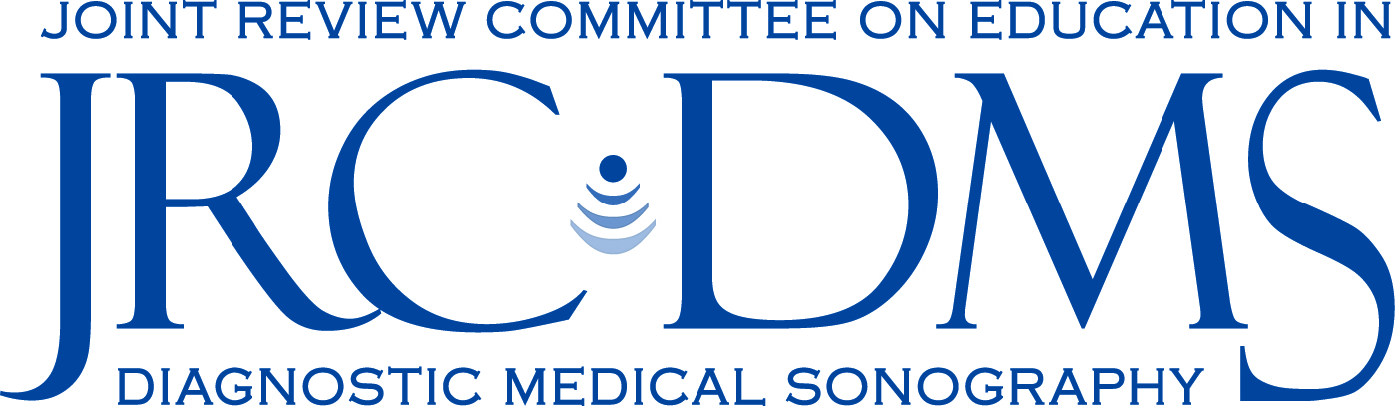

Request for Recognition of Substantive Change

Date:
Institution:
Program:
Program Director:
Dean:
___________________________________________________________________________

Date of Planned Implementation:
Change Type(s):

Rationale for Change:

Description of Change:

For Curricular Changes Complete the Following (add rows as necessary):

New Curriculum-Major Courses |  | Current Curriculum-Major Courses
Course | Credit hours | Course | Credit hours
Total Major Core Semester Hours |  | Total Major Core Semester Hours

Summary of Changes:

How is the change communicated to the students?

What is the financial impact and notification to those affected by the curriculum change?

Please Complete

Indicate if the following policies and procedures related to the DMS program will be affected by this change. If yes, provide explanation and any related documents:

Sponsorship | Yes No | If yes, explain:
Program Goals and Objectives | Yes No | If yes, explain:
Number of Learning Concentrations | Yes No | If yes, explain:
Support Staff | Yes No | If yes, explain:
Clinical Site Resources | Yes No | If yes, explain:
Faculty | Yes No | If yes, explain:
Medical Advisor | Yes No | If yes, explain:
Admissions Procedures | Yes No | If yes, explain:
Technical Standards | Yes No | If yes, explain:
Prerequisite GPA | Yes No | If yes, explain:
Required Number of Clinical Hours | Yes No | If yes, explain:
Course Assessment Methods | Yes No | If yes, explain:
Clinical Assessment Methods | Yes No | If yes, explain:
Program Assessment Methods | Yes No | If yes, explain:
Program Budget | Yes No | If yes, explain:
Library Resources | Yes No | If yes, explain:
Lab Resources | Yes No | If yes, explain:

